DECISION MEMO
SEP and MTObjects Toy-Object Masking: Results, Risks and Recommended Production Strategy
Date: 17 August 2026
Scope: Four-fold optimisation on 40 calibration galaxies and aligned eight-panel application to 182 galaxies
Decision: Select a masking strategy that balances contaminant recovery against damage to galaxy structure and bar profiles
Status: Both algorithms completed; 182/182 PNG reports available for each method
Recommendation. Use MTObjects as the primary production algorithm. It achieved higher held-out toy recovery and a substantially safer upper masking tail. Retain SEP as a secondary diagnostic: agreement can raise confidence, while SEP-only components should not be accepted automatically. Quarantine either result when total masked area exceeds 15% or the isophote/bar-profile diagnostics show structural damage.

1. What was completed
Both methods used the same 40-galaxy fold membership: four rotations of 30 training galaxies and 10 held-out galaxies, with 40 Optuna trials per fold. Each candidate was compared on a common 40-galaxy injected evaluation set within its own run. Both selected models were then applied to all 182 galaxies to create aligned eight-panel PNG reports.
The corrected SEP run completed on 17 August 2026 with fold 4 selected and 182/182 successful PNGs. SEP detection was constrained to the original science image throughout optimisation and production; the earlier residual-image run was discarded. The MTObjects recovery follow-up selected fold 3 and also completed 182/182 PNGs. Neither final batch contains a failed row.
Important comparability caveat: the two cross-validation runs used the same fold membership but different random injection seeds and different objective formulas. Therefore their scalar objective scores must not be compared directly. The decision below uses shared metrics (toy recall, toy detection rate and masked fraction), plus the same-size production batches.

2. Selected models
Item | SEP | MTObjects
Winning fold | 4 | 3
Detection image | Original science image | Original science image
Detection threshold / move factor | Threshold 1.981 RMS | Move factor 0.805
Minimum area | 12 | 5
Deblending | 32 levels; contrast 0.0010 | MTObjects tree segmentation
Background | Mesh 32; filter 1 | Variance 0.000821
Dilation radius | 4 | 3
Maximum area | 4885 | 2987
Maximum elongation | 11.84 | 12.38

3. Cross-validation comparison
The four-fold held-out means summarise generalisation across all four rotations. The selected-candidate rows show each winner on its own common 40-galaxy injected evaluation set. Higher toy recall and toy detection are better; lower masked fraction is safer.
Metric | SEP | MTObjects | Interpretation
Four-fold held-out toy recall | 40.4% | 47.6% | MTObjects +7.1 percentage points
Four-fold held-out toy detection | 40.8% | 50.4% | MTObjects +9.6 percentage points
Four-fold held-out masked area | 4.9% | 7.5% | SEP lower by 2.6 points across folds
Winner common-40 toy recall | 45.4% | 50.7% | MTObjects higher; seeds differ between runs
Winner common-40 toy detection | 45.4% | 53.3% | MTObjects higher; seeds differ between runs
Winner common-40 masked area | 5.7% | 9.1% | SEP lower; seeds differ between runs
Pixel precision and pixel F-score are very low for both methods under the current diagnostic definition because any mask not overlapping injected toy truth is counted as false-positive area, including masks on real foreground sources. These columns are useful for consistent optimisation within a run, but they do not estimate real-world catalogue precision and should not be the primary algorithm-selection statistic.

4. Full 182-galaxy behaviour
Production measure | SEP | MTObjects | Preferred
Successful reports | 182/182 | 182/182 | Tie
Mean masked area | 8.8% | 8.9% | SEP (small difference)
Median masked area | 8.4% | 8.8% | SEP
95th percentile masked area | 15.1% | 12.7% | MTObjects
Maximum masked area | 33.3% | 19.0% | MTObjects
Galaxies above 15% | 10 | 1 | MTObjects
Galaxies above 20% | 3 | 0 | MTObjects
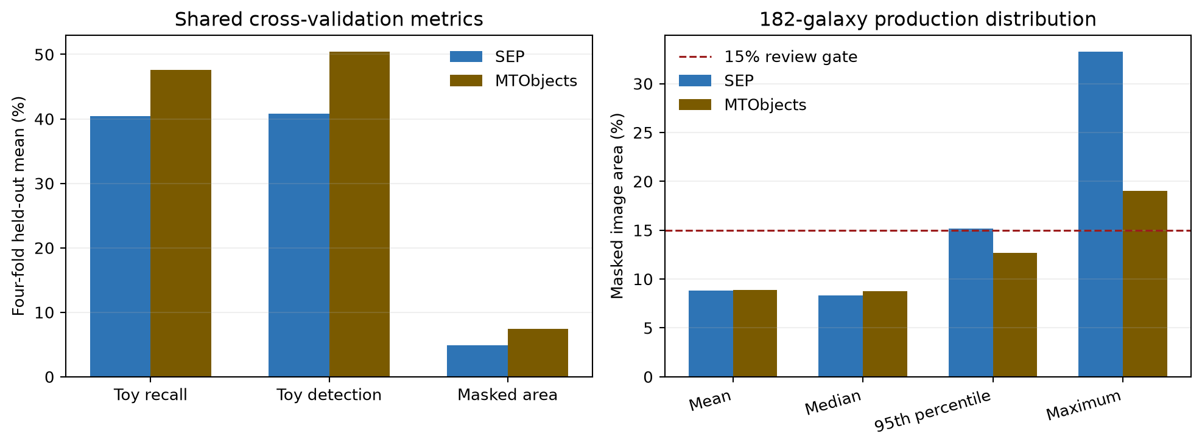
Figure 1. Shared recovery metrics and production masked-area distributions. The dashed line marks the proposed automatic review threshold.
On paired production galaxies, SEP masked less area than MTObjects in 121 of 182 cases; MTObjects masked less in 61. SEP was lower by 0.07 percentage points on average and 0.90 points at the median, so their typical masking burden was similar. The important difference was tail risk: SEP reached 33.3% on NGC1313 and exceeded 15% on 10 galaxies, whereas MTObjects peaked at 19.0% and exceeded 15% once.

5. Decision and operating recommendation

5.1 Recommended production workflow: MTObjects-led gated ensemble

Step 1: Run MTObjects first
Use MTObjects as the default mask generator and retain labelled components rather than only the final binary union.

Step 2: Use SEP as a diagnostic
Generate the science-image SEP mask for comparison. Agreement can raise confidence, but disagreement is a review signal rather than a reason to union both masks.

Step 3: Screen algorithm-only components
Apply size, elongation, central exclusion and bar-proximity rules. Prefer components with a PSF-like shape or an external catalogue match.

Step 4: Enforce image-level gates
If the candidate union masks more than 15%, if a single component dominates the mask, or if the processed bar-major profile changes beyond a defined tolerance, quarantine the image for review.

Step 5: Use a conservative fallback
For quarantined galaxies, review the component map, reduce dilation or tighten the maximum-area limit, and rerun. Never silently release a >15% mask.

5.2 If only one algorithm can be used
Unattended scientific processing. Use MTObjects. It achieved higher held-out toy recovery and the safer masking tail: one image exceeded 15%, compared with 10 for science-image SEP.

Secondary validation. Use SEP on the science image as an independent comparison, not as an unconditional union mask. Review disagreements and every >15% result.

6. Recommended objective-function changes
Change | Recommended implementation
Hard feasibility constraints | Reject a trial if any calibration image exceeds 15%, if toy detection falls below a minimum, or if bar-profile damage exceeds tolerance. Do not rely only on a soft mean penalty.
Worst-case or CVaR loss | Penalise the worst 10% of galaxies, or the mean of that tail, so an apparently good average cannot hide 25-42% masking outliers.
Component-level recovery | Reward the fraction of toys with a minimum overlap and use per-toy recall. Penalise false components and false component area separately, rather than allowing large real-source masks to dominate pixel precision.
Profile-preservation term | Add robust differences in the bar-major profile, isophote ellipticity/position angle and central surface-brightness gradient. Weight damage near the bar more strongly than damage far outside it.
Multi-objective optimisation | Optimise toy recovery, false-mask area and profile distortion as separate objectives and select from the Pareto front. This makes the scientific trade-off visible rather than hiding it in one arbitrary scalar.
Repeated injection seeds | Repeat each fold with several toy seeds and optimise the median plus a lower-tail recovery statistic. Current SEP and MTObjects comparisons use different evaluation seeds.
Real-foreground validation | Add a small manually annotated set of genuine stars and background galaxies. Injected toys are controlled but cannot fully represent PSF wings, diffraction features or complex background galaxies.

7. Alternative masking approaches

7.1 Catalogue- and PSF-assisted masks
For point sources, use astrometric catalogue matches (for example Gaia) and empirical PSF growth curves to define masks that expand with brightness. This can reduce confusion between compact galaxy structure and foreground stars. It should be combined with image detection for uncatalogued or extended contaminants.

7.2 Photutils segmentation
Photutils SourceFinder offers threshold detection plus multi-threshold watershed deblending, with explicit minimum-pixel, level and contrast controls. It is a useful independent implementation for an ensemble or a third benchmark, but it still needs the same toy-recovery and galaxy-damage objective.

7.3 NoiseChisel and Segment
GNU Astronomy Utilities provides a noise-based detection paradigm and a separate segmentation stage designed for diffuse astronomical signal. It is worth benchmarking where background estimation or low-surface-brightness wings defeat fixed thresholds. For this project it must be configured to protect the target galaxy, because its strength at finding diffuse signal can otherwise work against foreground-only masking.

7.4 Learned instance segmentation
Mask R-CNN and related instance-segmentation methods can jointly detect, classify and deblend sources. They are a longer-term option if sufficient labelled or realistic simulated training data can be assembled. They should not replace the current methods until tested on an external galaxy set and calibrated for uncertainty and profile preservation.

8. Immediate next actions
Priority | Action | Acceptance criterion
1 | Review SEP high-mask set | Inspect the 10 SEP reports above 15%, beginning with NGC1313, NGC3319, NGC4214, NGC1808 and NGC1800.
2 | Build component-level comparison | Save SEP and MTObjects labelled components, compute overlap and apply agreement/disagreement review rules.
3 | Add release gates | Fail or quarantine outputs above 15% masked area or above a bar-profile/isophote damage tolerance.
4 | Re-optimise robustly | Use hard constraints, tail-risk loss, repeated toy seeds and a manually annotated real-contaminant validation set.
5 | Benchmark one independent method | Start with Photutils for implementation comparability; test NoiseChisel if diffuse-wing/background failures remain important.

9. Sources and audit trail
- Project SEP results: D:\Dropbox\Public Documents\UCLAN\MSc Research\Remove foreground objects\sep toy cross validation\20260817_161404
- Project SEP production summary: D:\Dropbox\Public Documents\UCLAN\MSc Research\Remove foreground objects\SEP all galaxy batch\sep_toy_cv_20260817_161404\sep_optimised_apply_summary.csv
- Project MTObjects results: D:\Dropbox\Public Documents\UCLAN\MSc Research\Remove foreground objects\mtobjects toy recovery followup\20260816_063455
- Project MTObjects production summary: D:\Dropbox\Public Documents\UCLAN\MSc Research\Remove foreground objects\mtobjects all galaxy batch\mtobjects_toy_recovery_20260816_063455_eight_panel_aligned\mtobjects_optimised_apply_summary.csv
- Holwerda, Guide to Source Extractor: D:\Dropbox\Public Documents\UCLAN\MSc Research\SourceExtractor\Guide2source_extractor.pdf
- SEP extract API documentation: https://sep.readthedocs.io/en/latest/api/sep.extract.html
- Photutils SourceFinder documentation: https://photutils.readthedocs.io/en/stable/api/photutils.segmentation.SourceFinder.html
- GNU Astronomy Utilities NoiseChisel documentation: https://www.gnu.org/software/gnuastro/manual/html_node/NoiseChisel.html
- Burke et al. (2019), Deblending and Classifying Astronomical Sources with Mask R-CNN: https://doi.org/10.1093/mnras/stz2845

